[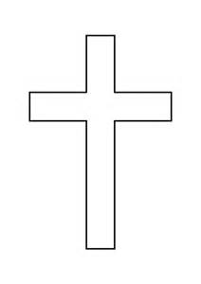](http://www.bing.com/images/search?q=+croix&view=detailv2&&id=09CF71F30EDD1FEF897E3B564B5823D9FE0E6759&selectedIndex=39&ccid=ej/zEdSB&simid=608008490393403692&thid=OIP.M7a3ff311d481f48a2daf60bc1521773ao0)



In the hope of the resurrection of the dead, we deeply regret to share with you the call to God of:

**Brother RAKOTONIRINA Olivier, FSC**

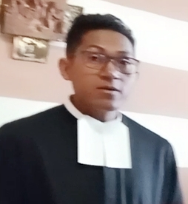

Death occurred on Monday, April 01, 2024 in his 40th birthday, including 12 years of religious life in the Institute of the Brothers of the Christian Schools.

From:

H.E. Msgr. Jean de Dieu RAOELISON, Archbishop of Antananarivo,

H.E. Archbishop Tomasz GRYSA, Apostolic Nuncio,

Reverend Fathers Vicars General,

Dear Brother Armin LUISTRO, FSC, Superior General of FSC,

Dear Brother Julien RATSIMBAZAFY, FSC, Provincial Visitor,

Saint Joseph's Community, Ambohimangakely

His mother, siblings and all his family,

All the Brothers of the Christian Schools of Madagascar,

The great Lasallian Family of Madagascar,

Saint Martin Parish, Tsarahasina, Ambohimangakely,

Christ the King Parish, Manjakaray,

The Fokontany Androtra Ambohimangakely

The Fokontany Nanisana Iadiambola

The wake is held in the Great Hall of the Brothers in Soavimbahoaka. The funeral will be held in the Chapel of Saint John Baptist de la Salle in Soavimbahoaka on Wednesday, April 03, 2024, from 1 p.m., followed by burial in the Brothers' vault.

"For if we believe that Jesus died and rose again, let us also believe that God will bring back through Jesus and with him those who have died." 1Thes 4:14